TE2801 Creative Brief

# Digital Data Visualisation

You are tasked with creating interesting visuals generated from data sets which may be generated from

* Twitter API
* Network Sensors
* JSON Api
* A custom website to collect inputs (questionnaire)

From the scenarios in this document, you will pitch to generate a solution using that data to either create data dashboard or data art.

**Data Dashboard Data Art**

 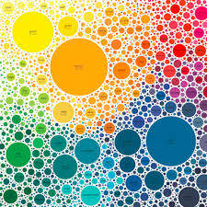

## Technical Requirements

The data will be brought in as simple integer variables that should be fed into your visual generation code (in HTML 5 canvas) and should use semi-structured data (JSON) to manage the information going to the visual display system.

Things to consider when coming up with creative solutions for the data are

* Frequency of data change (how often)
* Amplitude of data change (how much)
* What visuals suit the data types: visual representation/metaphor

The data should be ‘live generated’ There are only limited integers needed to be successful, it is about creativity not volume of data

Set 1: Basic JSON Integers (Random number + other meta data)

Data set is this string that randomises every 10 seconds

[{"name":"TRUCKEE","time":1520862885000,"sales":4,"longitude":"-120.186383","latitude":"+39.378100"},  
{"name":"LAKE ARROWHEAD","time":1520862885000,"sales":1,"longitude":"-117.129213","latitude":"+34.209221"}]

We normally just take the sales number from this string as the basis for our creative output

Set 2: Mesh Network JOSN Feed (more complex JSON from live networking device.

These network units are collecting data every 30 seconds

**{"network_id":232940,"node_mac":"AC:86:74:6F:19:40","version":1,"probe_requests":[  
{"mac":"00:ec:0a:de:3c:03","count":4,"min_signal":-83,"max_signal":-80,"avg_signal":-81,"last_seen_signal":-83,"first_seen":1520861743,"last_seen":1520861743,"associated":false},  
{"mac":"0c:8f:ff:29:aa:df","count":1,"min_signal":-84,"max_signal":-84,"avg_signal":-84,"last_seen_signal":-84,"first_seen":1520861742,"last_seen":1520861742,"associated":false},  
{"mac":"16:ac:04:89:a5:38","count":1,"min_signal":-88,"max_signal":-88,"avg_signal":-88,"last_seen_signal":-88,"first_seen":1520861757,"last_seen":1520861757,"associated":false},  
{"mac":"18:e7:f4:ae:51:14","count":1,"min_signal":-87,"max_signal":-87,"avg_signal":-87,"last_seen_signal":-87,"first_seen":1520861754,"last_seen":1520861754,"associated":false},  
{"mac":"2a:12:61:f7:e8:43","count":4,"min_signal":-85,"max_signal":-60,"avg_signal":-70,"last_seen_signal":-85,"first_seen":1520861760,"last_seen":1520861760,"associated":false }**

The real JSON is bigger, but that isn’t an issued.

Useful data and as a minimum you could always just use the count digit. You don’t have to use all of the data, but you could create quite a nice little map based on signal strength or calculate the difference between the maximum and minimum rather than just using the average.

Not as scary as it looks

Set 3: Questionnaire form data comparison (make a form, compare the answers to oxidising data)

You will need to create a short questionnaire of 10 questions, each with scale of 0 to 5? so that the whole questionnaire should generate a number from 0 to 50 when you add all of the answers up. This is a likert scale, used to gather people’s opinions on subjects.

The output generated is for comparison with a simple dataset of five ranges of opinion. Preferred output would not be a bar chart.

Artistic output can be anything generated from the form, which may be more related such as smiley faces or something else equally creative. Might be a nice one to use one of the physics engines.

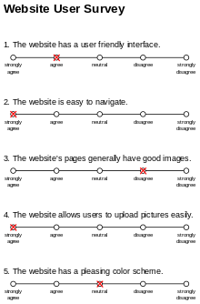

Set 4: Twitter (hashtag or account)

This challenge is where you can use both either hashtag or twitter user and generate an integer from the Jason API to create something arty or track trends.